

MINISTRY OF WATER RESOUSECES
AND METEOROLOGY

Department of Meteorology

Report on the state of meteorological service in

Cambodia

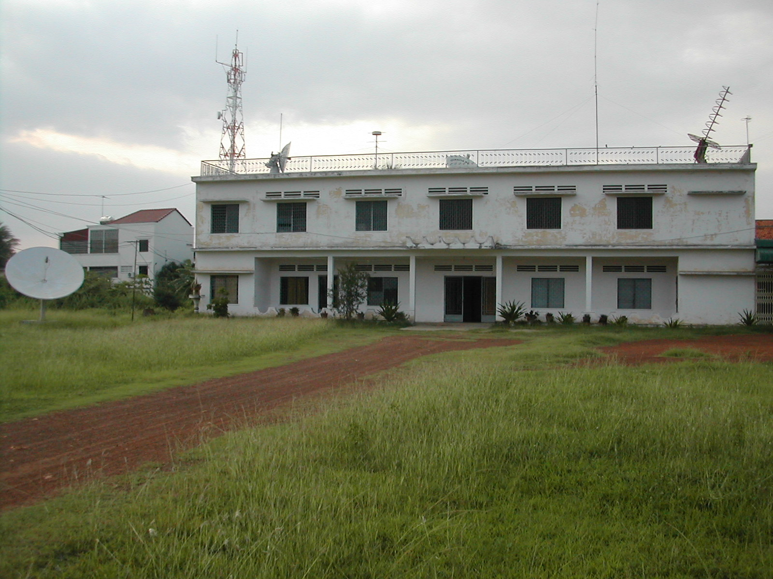

- Department of Meteorology

CONTENTS

INTRODUCTION 4
HISTORY 4-5
Organization 5-12
RECOMANDATION 13-14

HyDROLOGY.........................................................................................................................
DISASTER.............................................................................................................................

ACRONYMS

DOM - Department of Meteorology, Cambodia
GTS - Global Telecommunication System (GTS)
HF SSB - High Frequency Single Side Band.
ICAO - International Civil Aviation Organization
ITC - Illawarra Technology Corporation Ltd.
IATA - International Association of Airlines
JICA - Japanese International Corporation of Assistance
LOA - Letter of Agreement
METAR - Meteorological Aviation Report
MOWRAM - Ministry for Water Resources and Meteorology, Cambodia
MRC - Mekong River Commission
MWO - Meteorological Watch Office
NMHS - National Meteorological and Hydrological Services
SADIS - Satellite Distribution System
TAF - Terminal Aerodrome Forecast
UNDP - United Nations Development Program
WMO - World Meteorological Organization
WWW - World Weather Watch

INTRODUCTION

- Cambodia is located in Southeast Asia between : Latitudes 10-15o North and Longitudes 102-108o East. Bordered by : Laos in the North, Thailand in the North and Northwest, Vietnam in the East and Southeast, By the Gulf of Thailand to the Southwest.

- A total area of the country : 181,035sq Kilometers. The country consisted of 23 provinces and 3 municipalities and divided into 172 districts. 67% (12.1million ha) is classified as forest area. 21% (3.78 million ha) is cultivated area and 91% are occupied by paddy cultivation.

- The Climate in Cambodia is tropical, dominated by two main monsoons : The Southwest monsoon from mid-May until the mid- October. The Northeast monsoon from last of October to next May. Temperature : The variation of the mean annual temperature over Cambodia is very small. The mean maximum temperature in April 35 oC and the mean minimum temperature in December 21 oC. Absolute maximum temperature in April or May 42 oC. Absolute minimum temperature in December or January 14 oC. Humidity : The mean annual humidity over Cambodia varies in a norrow range among 75% at Phnom Penh, to about 80% at costal area.

- Cambodia is developing fast and meteorological data becomes more and more important for many sectors of Cambodia such as Aviation, Marine, Construction, Agriculture, Tourism, ...

- Weather and Climate seem to be more changeable and is becoming more unpredictable and more difficult to rely on be the normal.

- One year you have flood, next year drought and for some years you may have flood in one area and drought in another area.

HISTORY

History of meteorological service in Cambodia

Meteorological Observers was beginning observing since 1894. Meteorological services in Cambodia were not properly established until after independence in 1954. Prior to this, there had been minimum activity throughout the French occupation of the country.

Meteorological records exist approximately for the past 100 years and Cambodia joined the World Meteorological Organization in 1955. Until 1975 the meteorological services of Cambodia was undergoing expansion and capacity building. In the years from 1972 to 1975 an UNDP-funded project was introduced by the WMO.

Political instability and the rising to power of the Khmer Rouge led to the abandonment and disruption of the entire meteorological network and services. During the rule of the Khmer Rouge the number of qualified meteorological staff was significantly reduced from over 300 to only 10, and all equipment and facilities was destroyed. After 1979, with the assistance of the Soviet Union and Vietnam, a basic meteorological service was re-established. With equipment from the Soviet Union and Vietnam, 5 synoptic stations and 33 rainfall stations were re-established.

During 1992 and 1995 the meteorological network and services were partly rehabilitated through a Danida-funded project. The Danida-financed program was implemented by the Lutheran World Service as executing agency. During the 4 years between 1992 to 1995, the Cambodian meteorological network was upgraded, as the meteorological services. The program was led by experienced meteorological staff from the Danish Meteorological Institute and from The Australian Bureau of Meteorology. Over a period of four years the Cambodian meteorological service was brought up to a basic operational level. This was done with limited funds and often with low cost solutions. It was also during this period that Cambodia resumed its place in the World Meteorological Organization.

During 1996 and 1997 political instability again reduced was left the meteorological service to a very low operational level, once again Cambodia unable to fulfil its international obligations as stated in the WMO charter. A Japanese-funded project implemented by JICA during a three-year period between 2001-2003 established and upgraded some of the main synoptic stations and undertook on-the-job training” of DOM staff during 3-year period. The project focused on providing technical assistance and increasing the technical level.

Between 2005-2006 again Japanese-funded project for installing GTS-system connected link to Bangkok. From 2007-2008 by JICA funded project on Urgent Rehabilitation and Improvement of Civil Aviation Meteorology.

Responsibilities

To Prepare the plan for rehabilitation and development of the meteorology oceanographic and seismic throughout the country.
To establish and manage the meteorological, oceanographic and seismic stations.
To observe the weather conduction for the purpose of serving for all concerning sectors.
To collect and exchange the meteorological data in external and internal.
To forecast for the needs of various organizations and inform in advance the natural disaster.
To prepare the annual report on condition of meteorology in the Kingdom of Cambodia and other report, which are necessary for the Royal Government of Cambodia.
To strengthen and broaden national and international cooperation on Meteorology.
To research on natural disaster phenomena related to the Climate & seismology.
Provide consulting services on meteorology, oceanographic and seismic.
Undertake studies of scientific researches on meteorology, oceanographic and seismic.
Undertake studies for the applied advanced science and technology, development and transfer technologies in meteorology, oceanographic and seismic.
Take in the preparation of rule, procedure and technology standards of meteorology, oceanographic and seismic.

ORGANIZATION

Organization of meteorological service in Cambodia:

Initially the Ministry of Water Resources and Meteorology, was a department of the Ministry of Agriculture forestry and fisheries, named Department of Agriculture Hydraulic and Hydrometeorology. The name was subsequently changed to General Directorate of Irrigation Meteorology and Hydrology.

In 1998 the General Directorate was transformed into a Ministry and named Ministry of Water Resources and Meteorology, with meteorology as a department within the ministry.

H.E. Lim Kean Hor, is the Permanent Representative to the World Meteorological Organization (WMO).

The DOM is responsible for meteorological activities in Cambodia relating to ministries and the public. It is responsible for the collection, cataloguing and dissemination of meteorological data from all meteorological stations. However as most of the meteorological stations are located in different provinces, the respective province is responsible for staffing meteorological stations. The provincial authorities are responsible for allocating land and for staffing the stations. DOM is responsible for the equipment (installation and maintenance). Furthermore DOM is responsible for educating and training provincial staff. The only station staffed by DOM is the main station at the DOM headquarter in Phnom Penh.

DOM headquarters is located in the Pochentong area, just opposite to Phnom Penh international airport. DOM has been located at the same site since the re-establishment of the Cambodian Meteorological Service in the early eighties. The DOM compound is relatively large and comprises of approximately 20.000-30.000 square meters of land. The DOM building was built in the mid-80s of the typical USSR model and method of construction. The building is large, has lots of available office space, but is also in great need of maintenance.

DOM is divided into sections:

- Section/office for Forecasting
- Section/office for Equipment
- Section/office for Observation
- Section/office for Climate
- Section/office for administration
- Section/office for information and research

Department of Meteorology staff (Government staff)

48 staff, of which

- 5 are trained forecasters (science's meteorologist) with international education (Russia and Vietnam)
- 7 are internationally educated technicians (Russia and Vietnam)
- 17 are technicians educated nationally (JICA Training course)
- 19 have high school diplomas or equivalent

Work at the Provincial synoptic stations is carried out by staff from the provincial administrations. Each synoptic station has 2 trained weather observers. The total number of staff is 43, all of whom are Cambodian educated and qualified weather observers.

The operations of the Department of Meteorology

(a) Section/Office for observation:

Observational network:

The meteorological network in Cambodia consists of:

- 20 synoptic stations comprising of:
      - 9 automated stations (was broken)
      - 20 manual stations
        - 200 manual rainfall stations

Collection of data:

Synoptic data is collected by the 20 stations. Nine stations have been broken.

20 synoptic stations are equipped with manual observational equipment.

After collection of data (manual) it is recorded in the observation log, and transmitted to DOM in Phnom Penh by telephone and by HF SSB. After reception the meteorological data is transferred first to the forecasting section for use in forecasting and also transmitted to the climate section for climatological use.

Collection of rainfall data are carried out at all 200 rainfall stations by a local observer. Observations are recorded in a logbook provided by the DOM and when it is full it is taken to provincial head quarters and from there sent to DOM in Phnom Penh. The data is then analyzed and stored by the Climate Section/Office.

Transmission of data

Cambodia has connection to the Global Telecommunication System (GTS) and transmitting data in not real time yet.

The Observation Section/Office is responsible for one synoptic station in Cambodia - the central station located within the premises of the DOM.

These automated stations observe parameters are as follows:

Wind – direction and speed
Temperature
Humidity
Solar insulation

Measurements of evaporation and soil temperature are taken manually, using normal equipment. These measurements are recorded on a memory chip and this chip is changed twice a day. The recorded data is then logged into a database, printed out and given to the climate section.

The DOM observers are also responsible for collecting information from provincial stations. This is done by SSB HF radio and Telephone. Information is collected every 3 hours and relayed to forecasters who record and log the data into collection tables before passing it on to the climate section for inclusion in climate records.

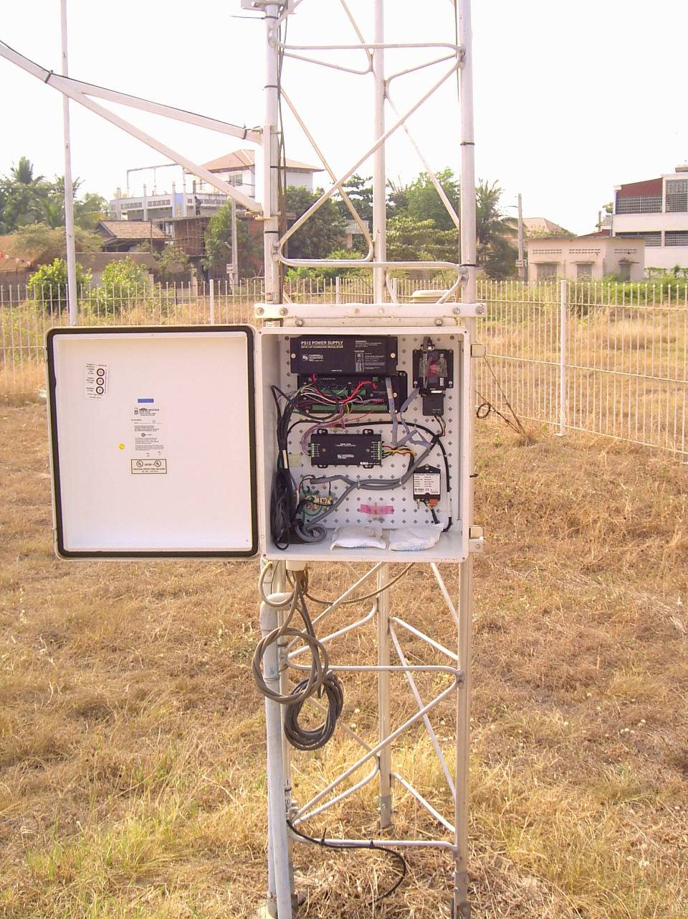

Automatic synoptic weather station at Department of Meteorology Phnom Penh.

(b) Forecasting Section/Office

The forecasting office is the best-equipped office in the DOM. There are a number of functioning computers. The DOM is connected via modem to the internet through ordinary telephone lines. This internet connection is the only way by which the DOM is able to communicate internationally. Facsimile communication is also available. (This option is not feasible, however, as international telecommunication is quite expensive). The Ministry of Water Resources and Meteorology covers all expenses related to national telecommunication.

Through the Internet it is possible for the forecasters to get limited access to satellite pictures from geostationary satellites and from polar orbiting satellites. However there is a delay in retrieving information via the Internet. Forecast products are also available from various sites on the Internet.

By using information retrieved via the Internet and local synoptic information, the forecasters are able to produce basic forecasts for different locations in Cambodia, including warnings for land areas. At this time no maritime forecasts are disseminated at all. Warning for shipping in coastal areas is also non-existent.

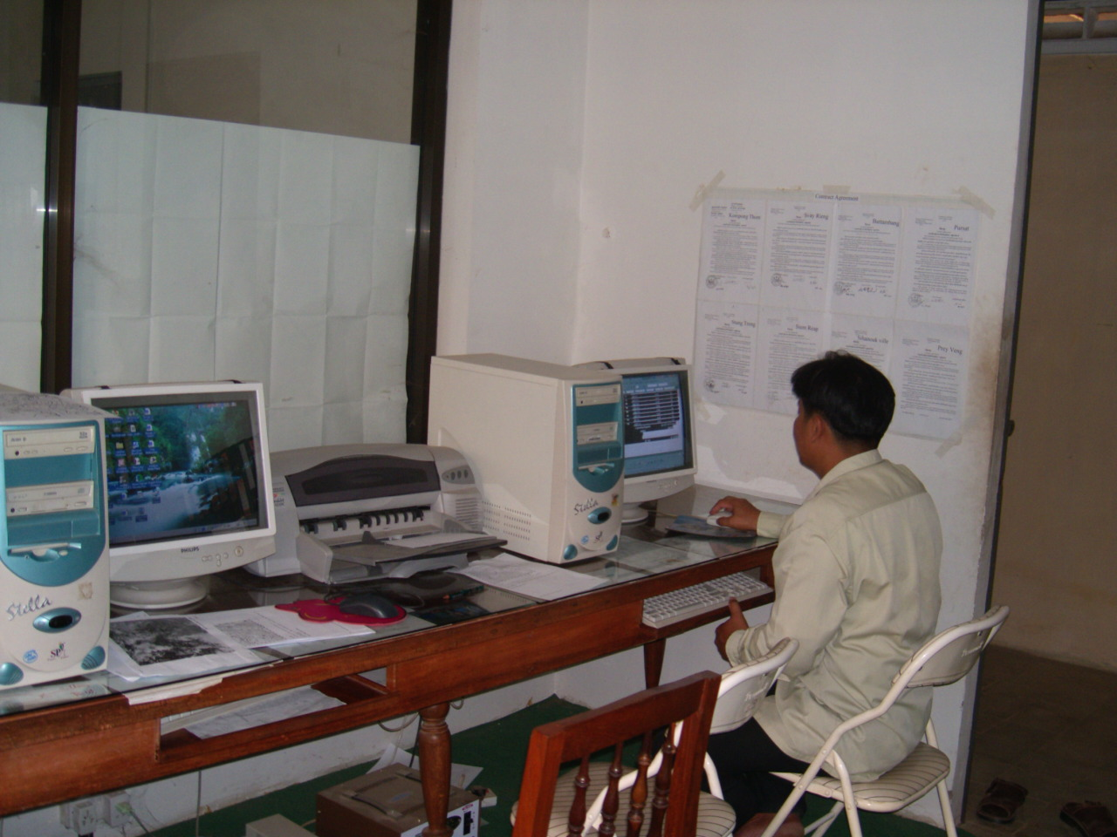
Section for forecasting – Department of Meteorology Phnom Penh

(c) Equipment Management Section/Office

This section is responsible for the nation-wide installation and maintenance of all meteorological equipment including communication and computing equipment in all other sections.

(d) Climate Section/Office

As this mission focused on the possibility of providing Cambodia with the capacity to independently produce its own forecasts and in the longer term to also provide national as well as international institutions with quality data locally, emphasis was directed at the current status of the forecasting, observation and managerial areas of the DOM. The responsibility of this Office is to collect meteorological data for the entire country, to apply quality control of the collected date and to absorb it into the climatological database for Cambodia.

The DOM lacks basic storage facilities for climatological data. Currently all data is recorded into pre-printed recording books and stored in one dark room. All Cambodian climatological data is stored in the one room. Even data dating back to the beginning of the 20th century is stored here.

The resent Climate Office stating the database all the data from the beginning of the 20 th century.

(e) Management and Section/Office for Administratio:

The capacity of the staff at managerial level seems to have increased quite significantly compared to 1992/1993. The Director seems to be a capable individual with the ambition to develop the DOM into a more modern institution given the right circumstances and proper guidance, while at the same time developing the DOM into a national institution capable of performing the necessary tasks.

It should be mentioned here that while the DOM may be the national institution dealing with meteorology, At this moment, no METAR information is issued by the historical reason. However, from 1985, METAR was originally issued from DOM.

According to the International Civil Aviation Organization (ICAO) in Bangkok, SSCA is listed in ICAO records as being both the authority on meteorology for civil aviation as well as the provider of meteorological services for civil aviation. For these matter SSCA and Ministry of Water Resources and Meteorology was discussed making agreement sign in 2005 for working such as Department of Meteorology will operate of the weather information to the civil aviation, and civil aviation as the user products from Department of Meteorology.

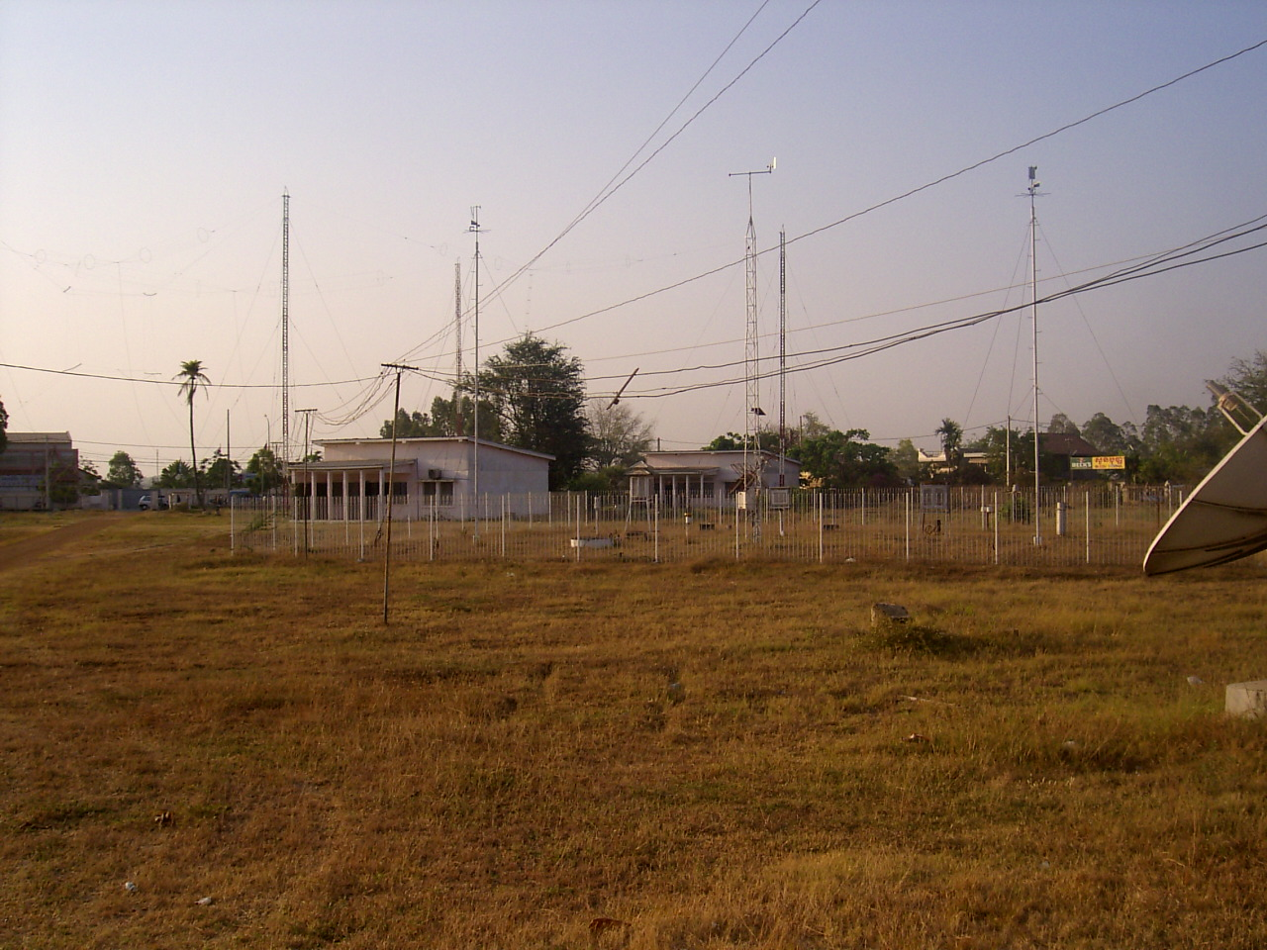
Synoptic station in Department of Meteorology – Phnom Penh.

In case of installing meteorological equipment, international specifications are needed to be met. When meteorological data is collected and exchanged it is of great significance that the data has been collected from instruments that are all installed according to these specifications so that all data is comparable.

The station was well maintained and the data was collected regularly, using the same routine as used in the main synoptic station in Phnom Penh. Data was passed on to the centre in Phnom Penh via SSB HF radio. Following an examination of the station a rain gauge was found. This rain gauge, having a remote reading capability, had been donated to the provincial department of hydrology and meteorology as a result of an unspecified Asian Development Bank project. There was uncertainty as to how many had been installed and where, and in what connection.

A manual river gauging station at the Pursat River. River running through Pursat empties into the Tonle Sap Lake. The station was in good condition, but the water level in the river was at its lowest point for at least 20 years, and also below the lowest measurable level.

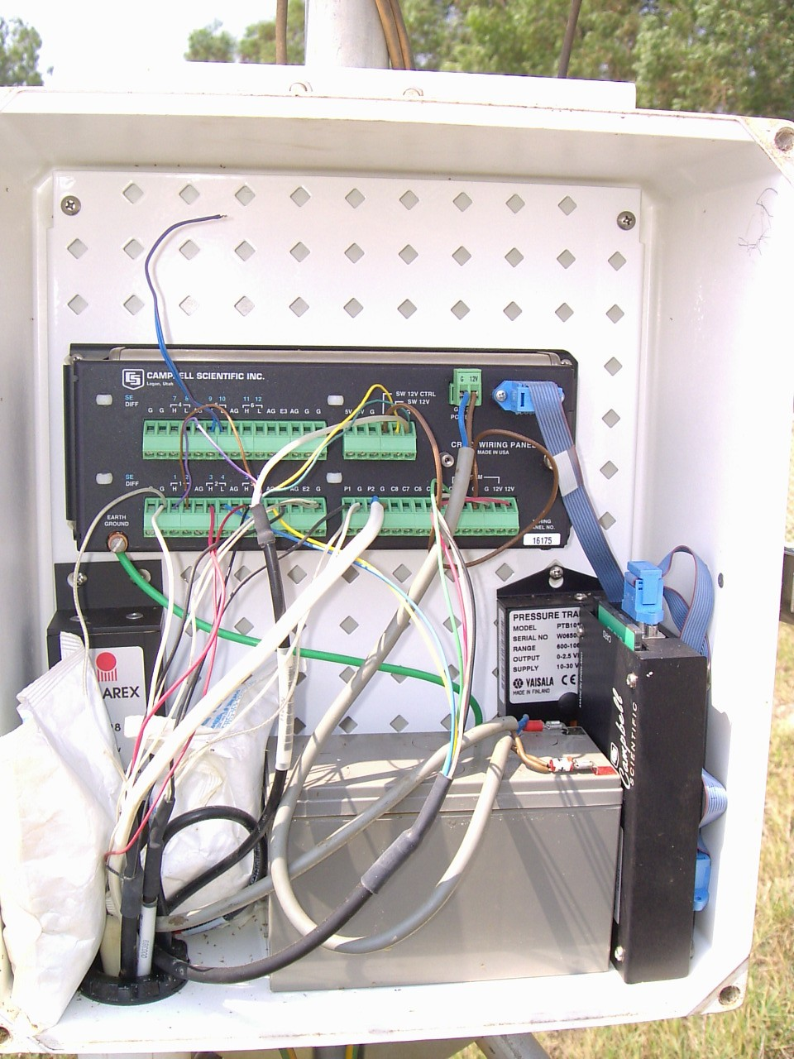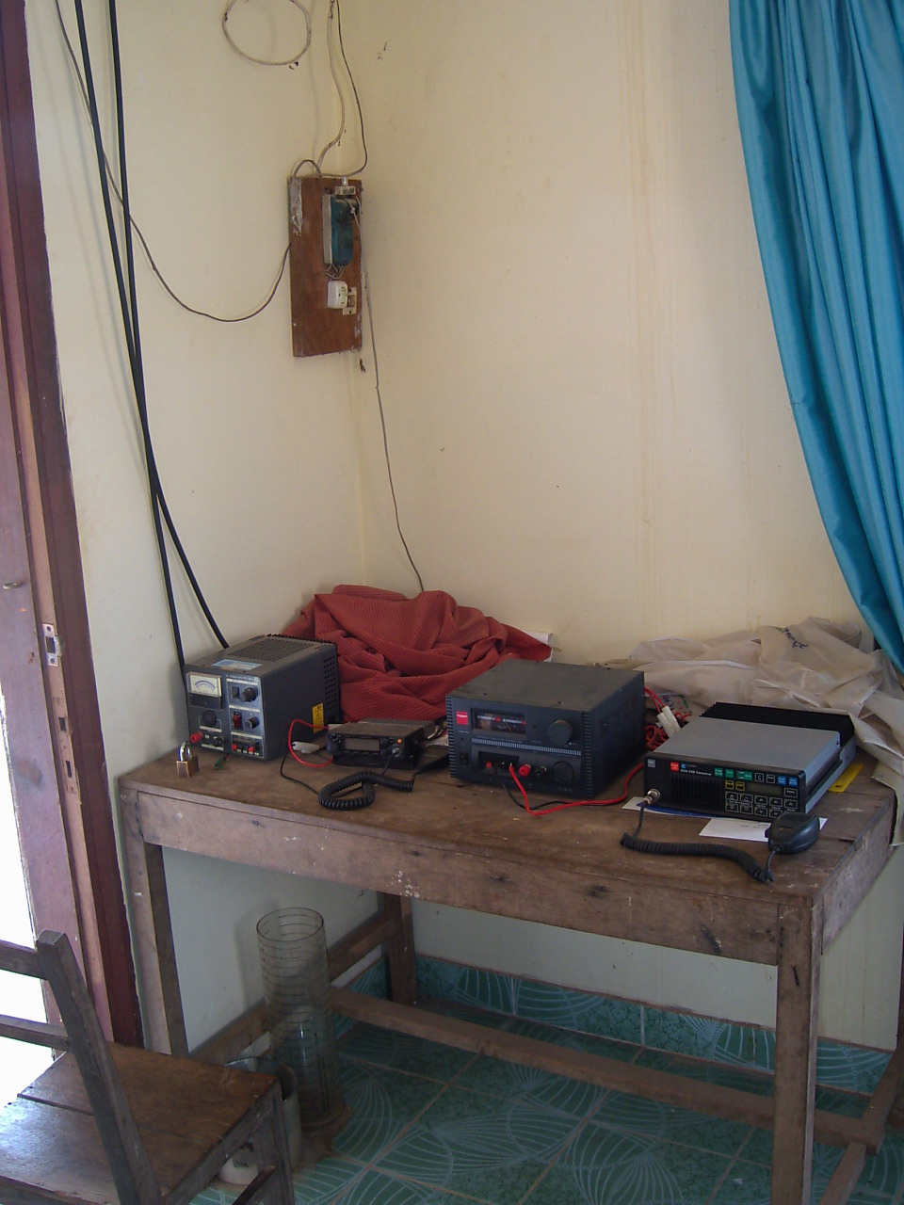
Automatic measuring station in Pursat SSB HF radio communication equipment.
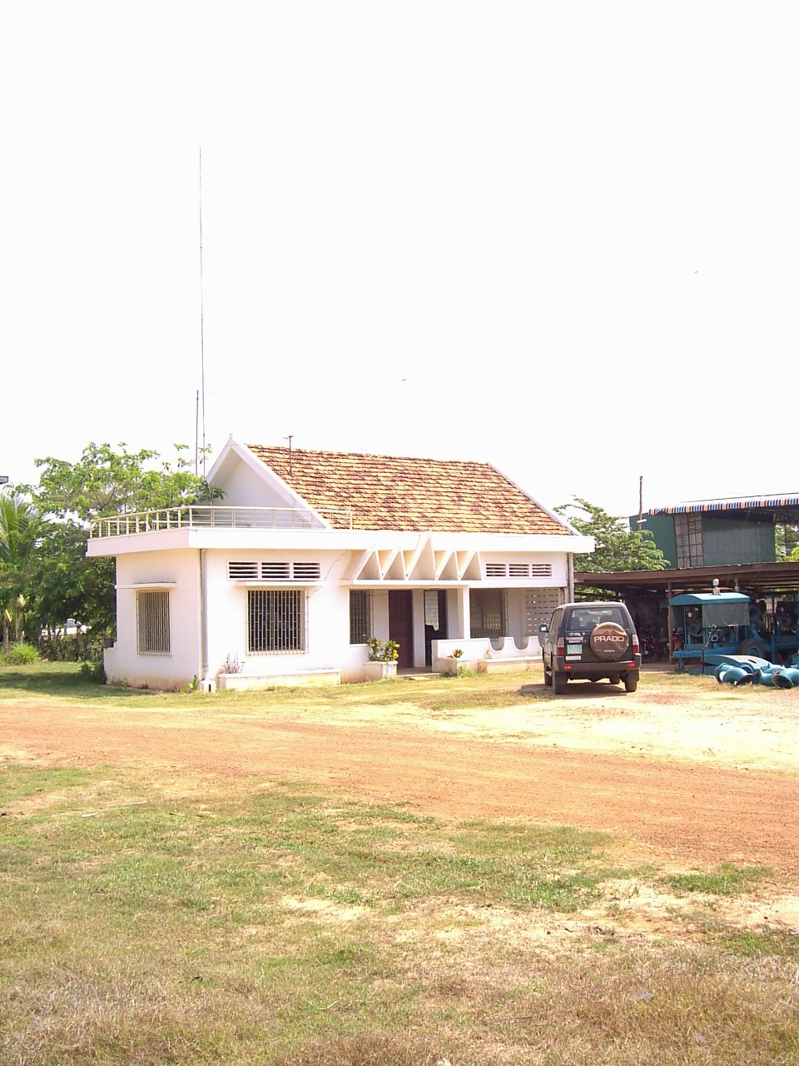
Pursat main synoptic station

The provincial staff working at the provincial meteorological and hydrological stations are all employed by the provincial governments. They perform both weather and water level observations. They also act as provincial centres for the collection of rainfall data.

The staff expressed interest in getting the station equipped properly, and the installation corrected to WMO standards. The staff also wanted to get a wired connection from the meteorological station to the computer inside the observation building. DOM were able to connect the computer to the station, but needed funds for any provincial travel and had only very limited means to carry out thorough maintenance.

COMENTS

In Cambodia:
- There is an urgent need for institutional strengthening;
- There is an urgent need for quality data;
- There is a need to provide assistance to maintain and develop the meteorological stations network.

For safety reasons:
- There is an extremely urgent need to assist the SSCA in providing a meteorological service for aviation;
- There is an extremely urgent need to strengthen the institutional capacity of the SSCA;
- There is an extremely urgent need to establish and name a provider in the area of meteorological service for aviation;
- There is an extremely urgent need to assist the Navigation in providing a meteorological service for Navy;
- There is an extremely urgent need to strengthen the institutional capacity of the Navigation;

In the national interest:
There is a need for Cambodia to formalize and implement a national policy for meteorology. But now Department of Meteorology is preparing the Meteorology Law in the country.

HYDROLOGY

- It has 124 hydrological stations.
- 30 automatic stations, it does not working.
- 42 floodplain.
- Method of flood forecasting : Regression Method and Station Relation Method.
- Type of Suction : 1. Staff Gauge, 2. Slope Gauge, 3. Automatic Water Level Recorder, and 4. 4 telemetry stations.

DISASTER

- By flood at Stung Treng, Kroties and Kompong Cham, where are upstream at Mekong River.
- A lot of drought almost in 24 provinces at the country on June, July and August 2008 .
- 6 tropical cyclone was effected as rainfall depression in Kompong Thom, Siem Reap, Battambang and Kompong Cham.
- 35 person was died by lightning and thunder.

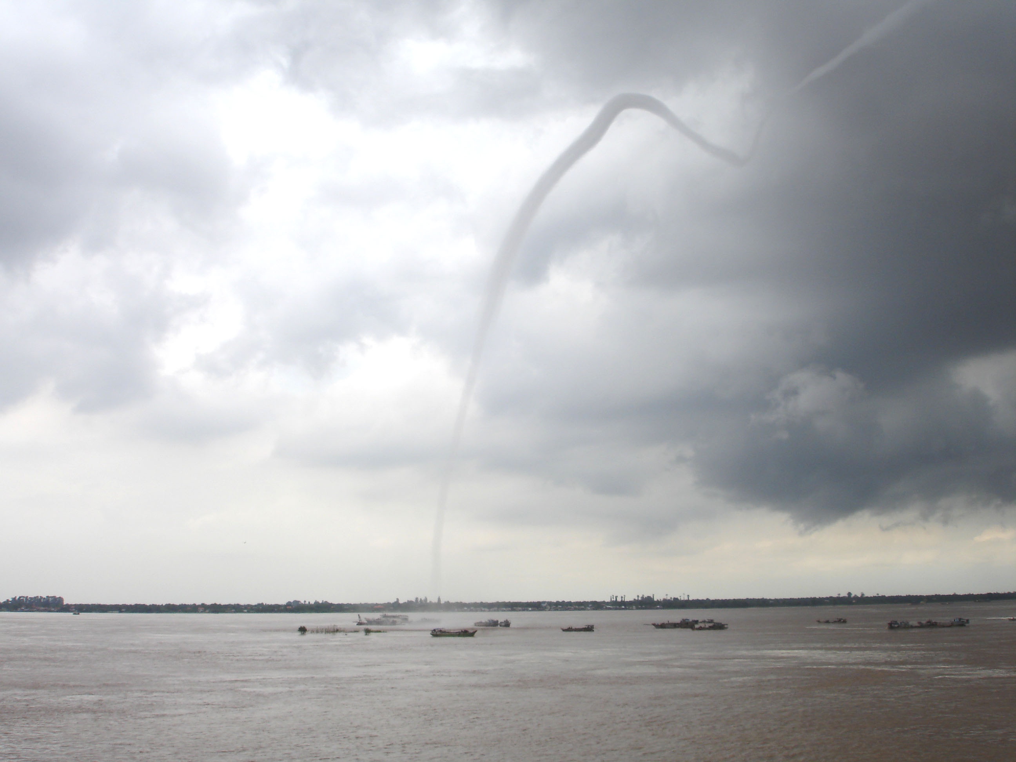
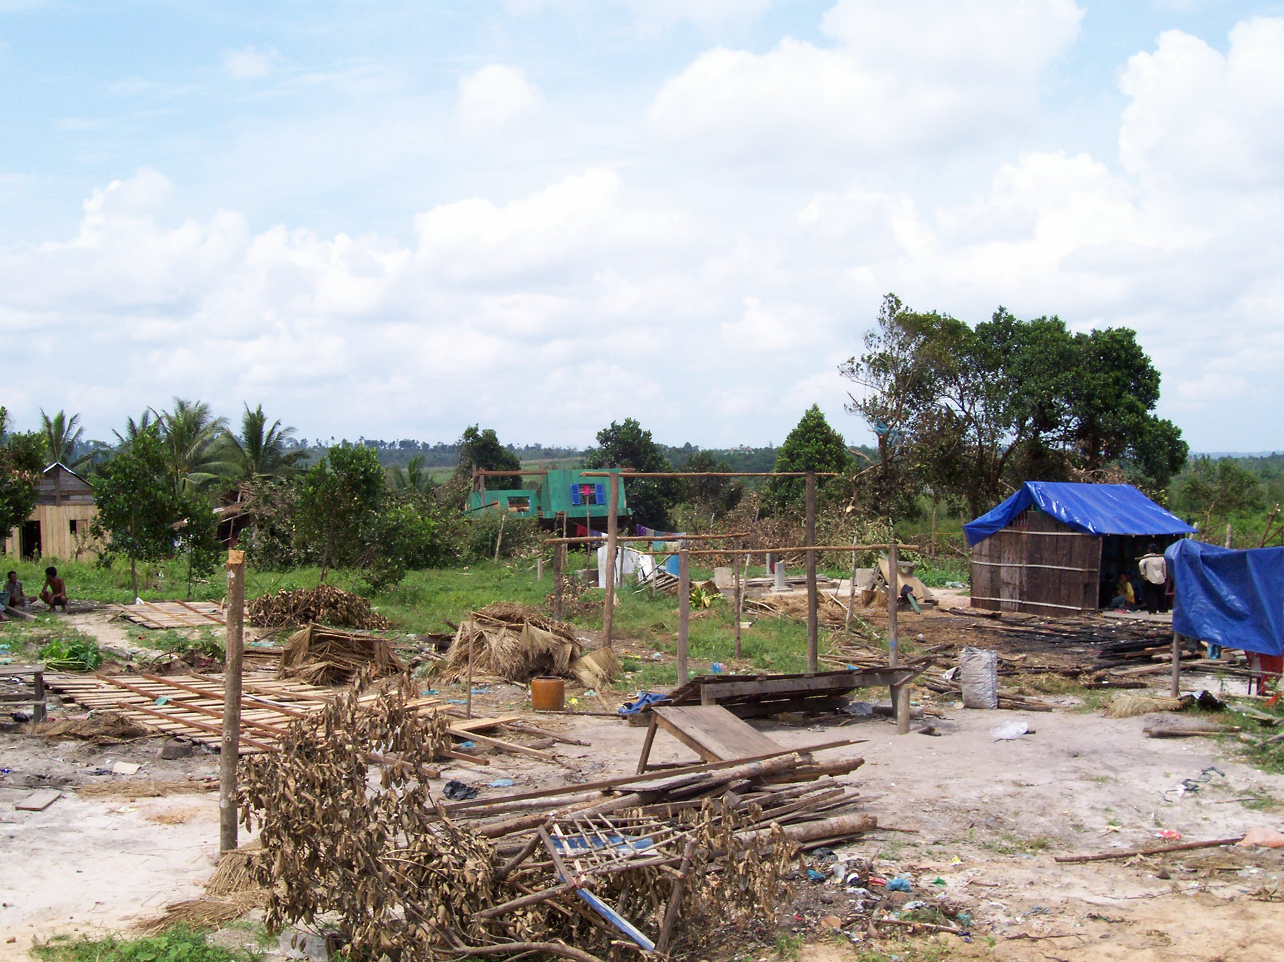
Strong Wind on April 19, 2006
Water Spout on August, 2006

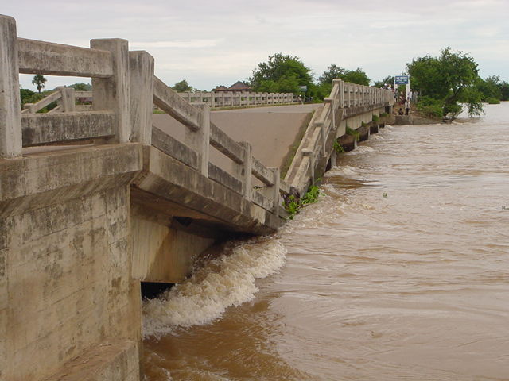
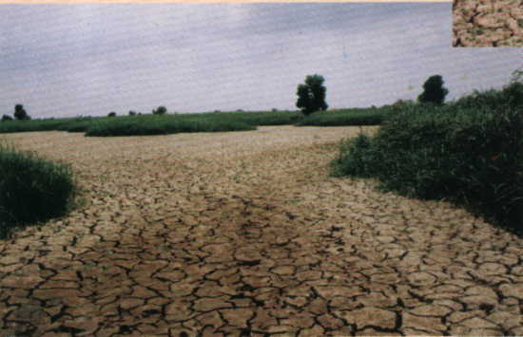
Flood in 2001
Drought in 2004

